

**Please state Index Number:**

|  |  |  |  |  |
| --- | --- | --- | --- | --- |
| **Student Name:** | | **Jumaev Sunnatullo Salohiddinovich** | | |
| **Student Number:** | | **B1904092** | | |
| **Course:** | | **Bachelor of Science (Hons) in Computer Information Systems for Business** | | |
| **Module Code and Title:** | | **ICP-1026 Web Technologies** | | |
| **Module Leader:** | | **Mr Lau Chong Teck Jackson** | | |
| **Module Tutor:** | | **Mr Castro Eugene** | | |
| **Assessment:** | | **Assignment 2 – Build an Image gallery for your webpage** | | |
| **Due Date:** | **24 January 2021** | | **Date Submitted:** | **25 January 2021** |
| **Weighting within Module:** | | **30%** | | |
| **ALL MARKS ARE PROVISIONAL AND ARE SUBJECT TO CHANGE UNTIL CONFIRMED BY THE EXTERNAL EXAM BOARD** | | | | |
| **Comments from Internal Examiner (Name):** | | | | |
| **Strengths:** | | | | |
| **Weaknesses:** | | | | |
| **Areas of Improvement:** | | | | |
| **Provisional Mark out of 100:** | | |  | |
| **ALL MARKS ARE PROVISIONAL AND ARE SUBJECT TO CHANGE UNTIL CONFIRMED BY THE EXTERNAL EXAM BOARD** | | | | |

Table of Contents

Introduction 3

Task No. 1 – Working with JSON String 4

Task No. 2 – Building a Gallery from a JSON string 5

Task No. 3 – Style your Gallery with CSS 6

Task No. 4 – Provide alternative backgrounds with CSS 7

# Introduction

The whole website is created by using HTML, CSS and JavaScript programming languages.

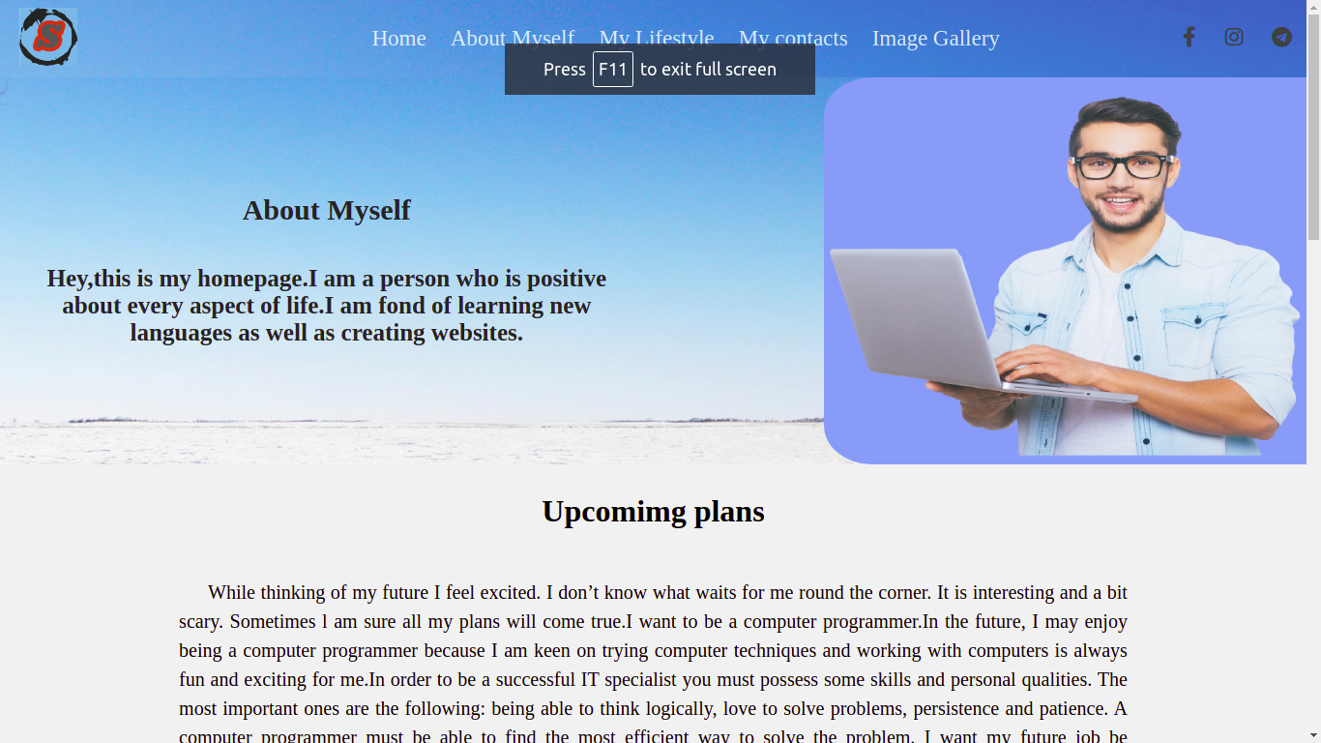

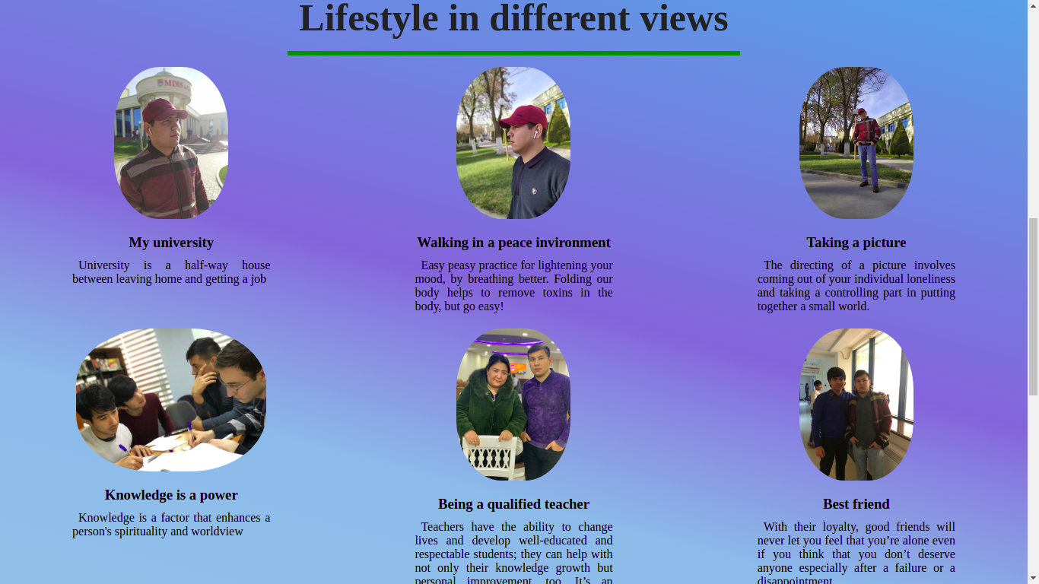

# Task No. 1 – Working with JSON String

In this website, Created a variable of JSON string that holds series of images ,

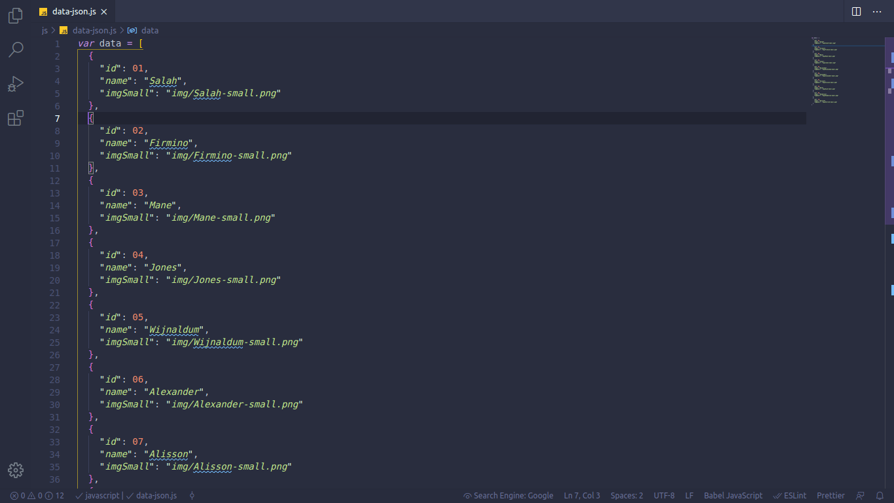

# Task No. 2 – Building a Gallery from a JSON string

Gallery page is created by using HTML , CSS, JavaScript

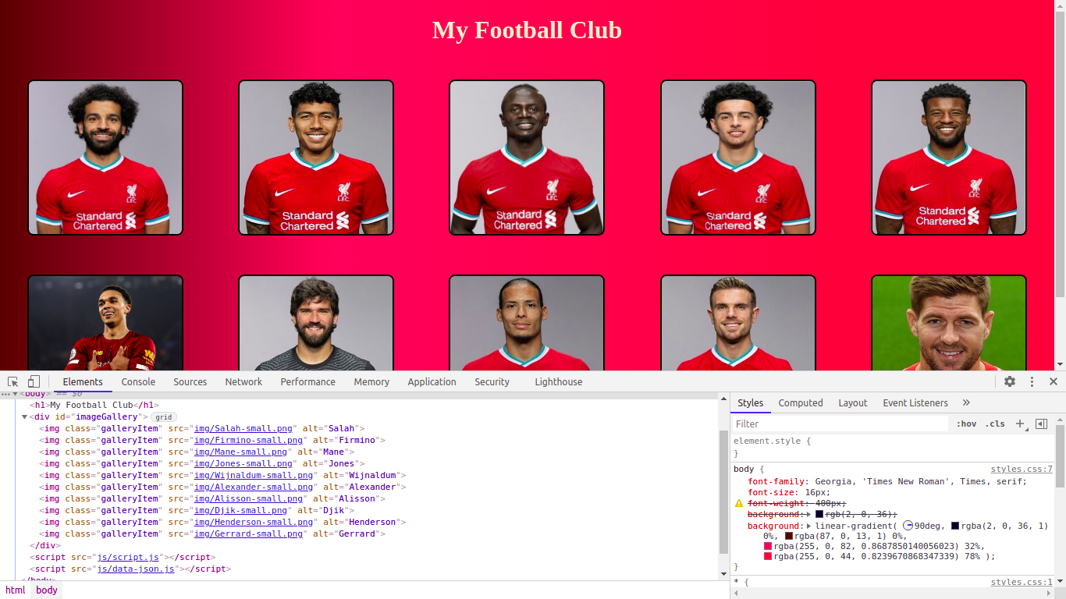

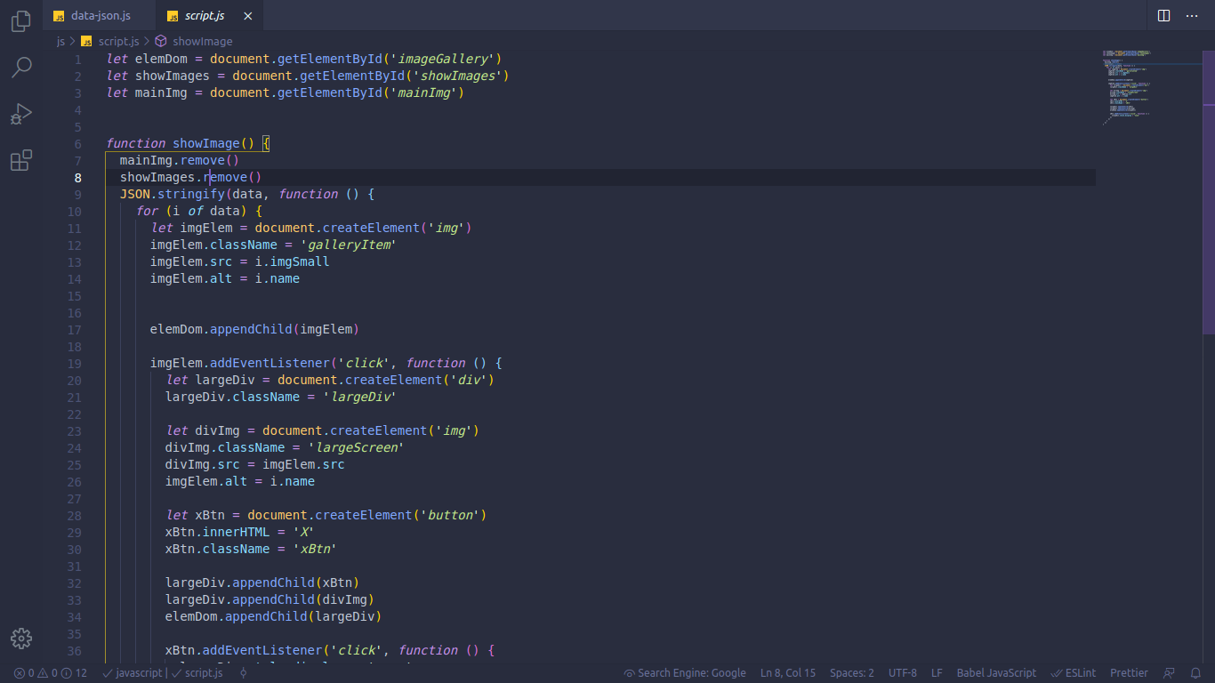

# Task No. 3 – Style your Gallery with CSS

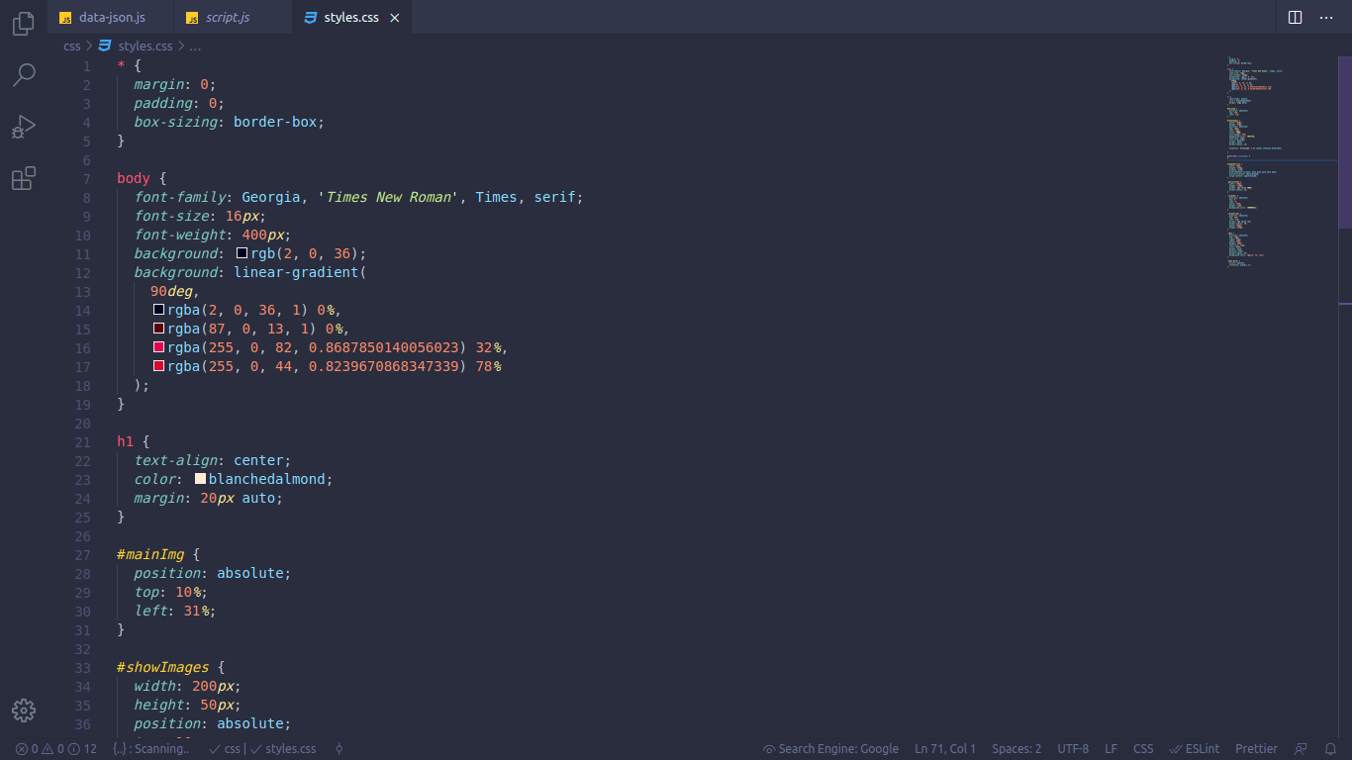

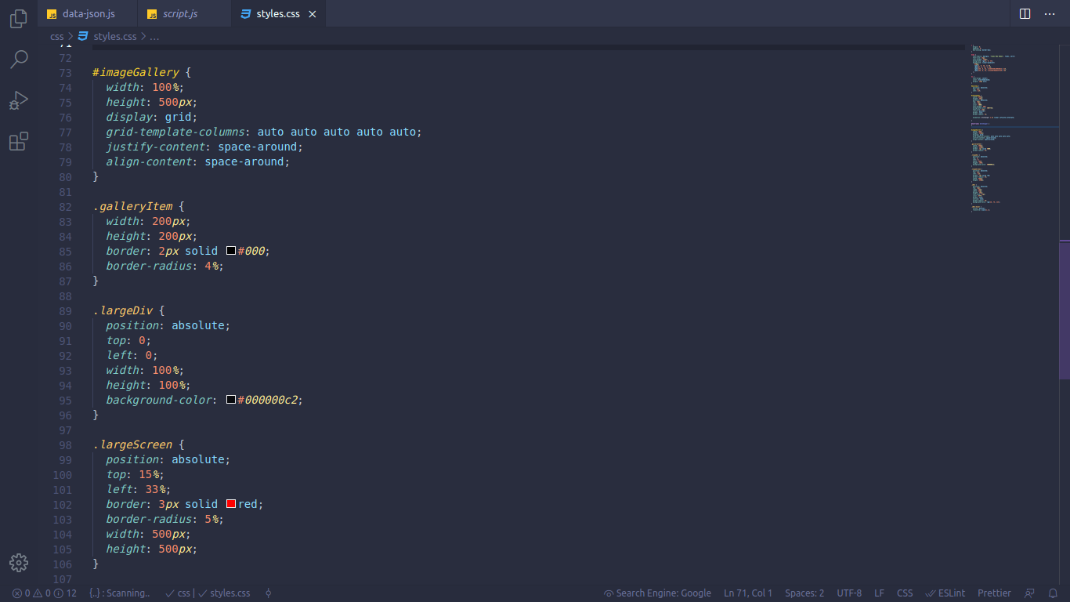

# Task No. 4 – Provide alternative backgrounds with CSS

